

Project Title

Subtitle (if any)



Project submitted in the context of the course   
I3301 Software Engineering

Prepared by   
Student Name 1  
Student Name 2

Lebanese University

Faculty of Sciences I

Department of computer Sciences

2023 - 2024

# Acknowledgements

If any…

# Abstract

your perfect itinerary with ViCaNzA! Trip planner application designed for vacations, and everyday adventure. Our advanced algorithms take into account selected sights, dining, and lodging preferences to create the optimal travel plan tailored for our customers, either inside or outside lebanon.  
  
Vicanza harnesses the power of social media by extracting travel insights from Instagram reels and TikToks, and incorporating them into their plans.  
  
It's not just a plan that we provide, but a total trip equipment, such as a comfortable way of transportation, places and restaurant reservations.  
  
Our customers can create their own account so they can post their spectacular experiences with ViCaNzA!

# Table of Contents

Acknowledgements 3

Abstract 4

Table of Contents 5

Table of Figures 8

Table of Tables 9

How to format your text in this document 10

Chapter I - Introduction 12

I.1. The business domain 12

I.2. About the modeled application (Purpose, Users Persona and Product Perspective) 13

I.3. Analysis of the Existing Similar Apps 13

I.4. Plan of the document 14

Chapter II - Requirement Analysis and Specification (extension of SRS document provided by IEEE) 15

II.1. Introduction 15

1.1. Purpose 15

1.2. Document Conventions 15

1.3. Intended Audience and Reading Suggestions 15

1.4. Product Scope 15

1.5. References 15

II.2. Overall Description 16

2.1. Product Perspective 16

2.2. Product Functions 16

2.3. User Classes and Characteristics 16

2.4. Operating Environment 16

2.5. Design and Implementation Constraints 16

2.6. User Documentation 16

2.7. Assumptions and Dependencies 17

II.3. External Interface Requirements 17

3.1. User Interfaces 17

3.2. Hardware Interfaces 17

3.3. Software Interfaces 17

3.4. Communications Interfaces 17

II.4. System Features 18

4.1. System Feature 1 18

4.2. System Feature 2 (and so on) 18

II.5. Other Nonfunctional Requirements 18

5.1. Performance Requirements 18

5.2. Safety Requirements 19

5.3. Security Requirements 19

5.4. Software Quality Attributes 19

5.5. Business Rules 19

II.6. Other Requirements 19

II.7. Requirements Gathering 19

II.8. Requirements Analysis 20

8.1. Use Cases 21

8.2. Use Cases Textual Description 21

II.9. High-Level Design Specification 22

II.10. Conclusion 23

Chapter III - Application Conception 24

III.1. Introduction 24

III.2. UML Class Diagram 24

III.3. Sequence Diagrams 24

III.4. State Chart Diagram 24

III.5. Conclusion 24

Chapter IV - Conclusion 26

IV.1. Future Considerations 26

Bibliography 27

Note about the bibliography [to be deleted from the final document] 27

# Table of Figures

Figure 1 Predefined Styles in this Document 10

Figure 2 References Ribbon 11

Figure 3 Mobile banking boom in recent years 12

Figure 4 Sample Sketch Mockup 20

Figure 5: Example for a DTD 22

# Table of Tables

Table 1 Comparison of Existing Similar Applications 13

1. Introduction

This chapter introduces the modeling of ViCaNzA application and the underlying business domain. It is a travel planner that brings both artificial intelligence and bespoke experience, making it hassle-free for travellers to create their ideal trip plans.

* 1. The business domain

Gone are the times when arranging an own trip became more of a challenge for people. Owing to technology escalation, it has now turned to be a smooth ride as the world has become more tiny and reachable for all of us.  
  
Today everything, be it a place you want to visit, a hotel to stay in, any food to taste is just at a distance of a few taps on your smartphone. There are a myriad of mobile apps to meet all types of trips and traveling needs.  
  
The travel planner app development companies have made things a lot easier, for instance, you can view the entire itinerary at just one location. All that needs to be done is forwarding travel planning details to your friends and the app creates a master schedule for each of your journeys that can be accessed anytime, anywhere, and thus the entrepreneurs are diverting towards investing in the niche.  
  
The Global Travel Planner App Market size is expected to be worth around USD 1,445.1 Billion by 2032 from USD 486.2 Billion in 2022, growing at a CAGR of 11.90% during the forecast period from 2023 to 2032. The market is being driven by the increasing popularity of online travel planning, the growing demand for personalized travel experiences, and the rising disposable incomes of people in developing countries.

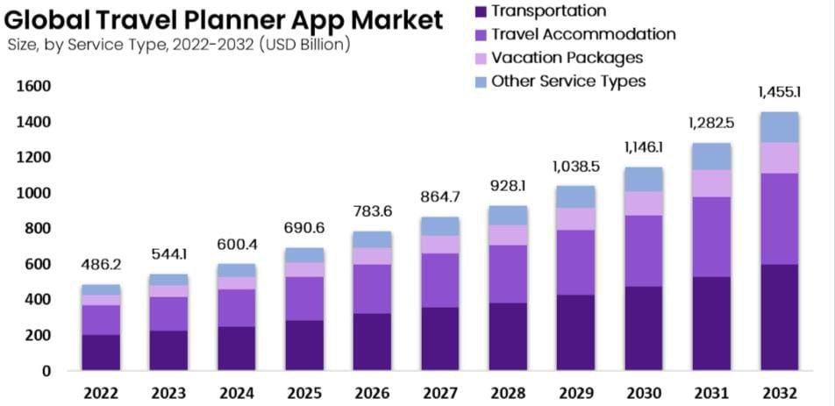

Figure 3 Global Travel Planner App Market

* 1. About the modeled application (Purpose, Users Persona and Product Perspective)

We’ve heard it often but many people ask us why someone would need a travel planner when nowadays it’s so easy to set up your own travel itinerary with all the info available on the internet? It’s true that there’s a huge amount of valuable information available but the more options there are, the more confusing for the consumer to figure out what is relevant. There’s an information overload which makes planning your own trip a very time-consuming job! Here’s where ViCaNzA trip planner comes in and saves so much time and stress prior to departure.   
  
ViCaNzA’s mission is to ease the travel planning process, have everything in one place and make it enjoyable to discover the world in your own way. ViCaNzA’s vision is being the easiest-to-use and most customer-centered travel planning platform.  
  
Travel Planner's main focus is to attract local and foreign tourists and travelers in search of excursions and leisure and quality time travel mainly in Arab countries, especially Lebanon. The company will be fully implementing the policy of supporting their moves to visit and enjoy the many attractions in the locality. Most of the visitors come from Europe, America, and Africa. Many of them lack the understanding of the geographical and locations networks in and therefore, lack the best means to access their places of interest and business visits. The company will professionally establish escorting platforms and facilities for these visitors so as to ensure convenience, security, and peace at the foreign lands.  
  
It can be difficult to keep track of everything that needs to be done without ViCaNzA. Finding available hotels for tourists can be a challenge if it’s unclear which hotels are good and empty.   
Waiting for a server can be a major inconvenience, especially if it’s crowded.   
Reservation need to be filled in a reasonable amount of time, while simultaneously ensuring that any special accommodations are accounted for. It is essential to suggest destinations, hotels, flights, and other related services with accuracy and speed to make sure of having a happy returning customer. And this is where ViCaNzA comes into play.  
  


ViCaNzA is a follow-on member for the various travel management systems offered   
nowadays. The travel industry is quickly evolving, especially with the growing demand for the personalized travel, and that   
won’t be changing soon. are demanding features that didn’t exist 20 years ago. The   
straightforward system designed to manage a trip is being replaced by all-in-one   
technology platforms that offer gift cards, online payment, and much more!

This chapter introduces the modeling of ViCaNzA application and the underlying business domain. It is a travel planner that brings both artificial intelligence and bespoke experience, making it hassle-free for travellers to create their ideal trip plans.

I.3 Analysis of the Existing Similar Apps

Similar applications for

FareFirst

Farefirst helps you find cheap flights and best hotel deals. It compares all the top travel sites in one simple search and help you to find the best flights and hotels. It also provides you the best offers, deals, and discounts on hotel booking.

### FareFirst Features

1. [Ad-free](https://alternativeto.net/feature/ad-free/)FareFirst doesn't contain any form of external advertising.

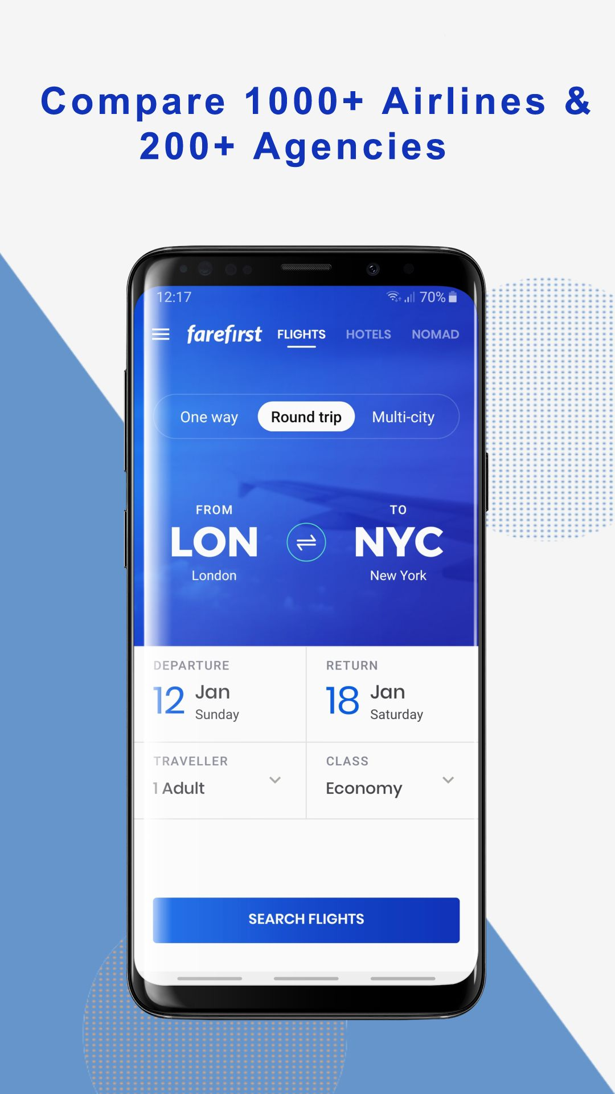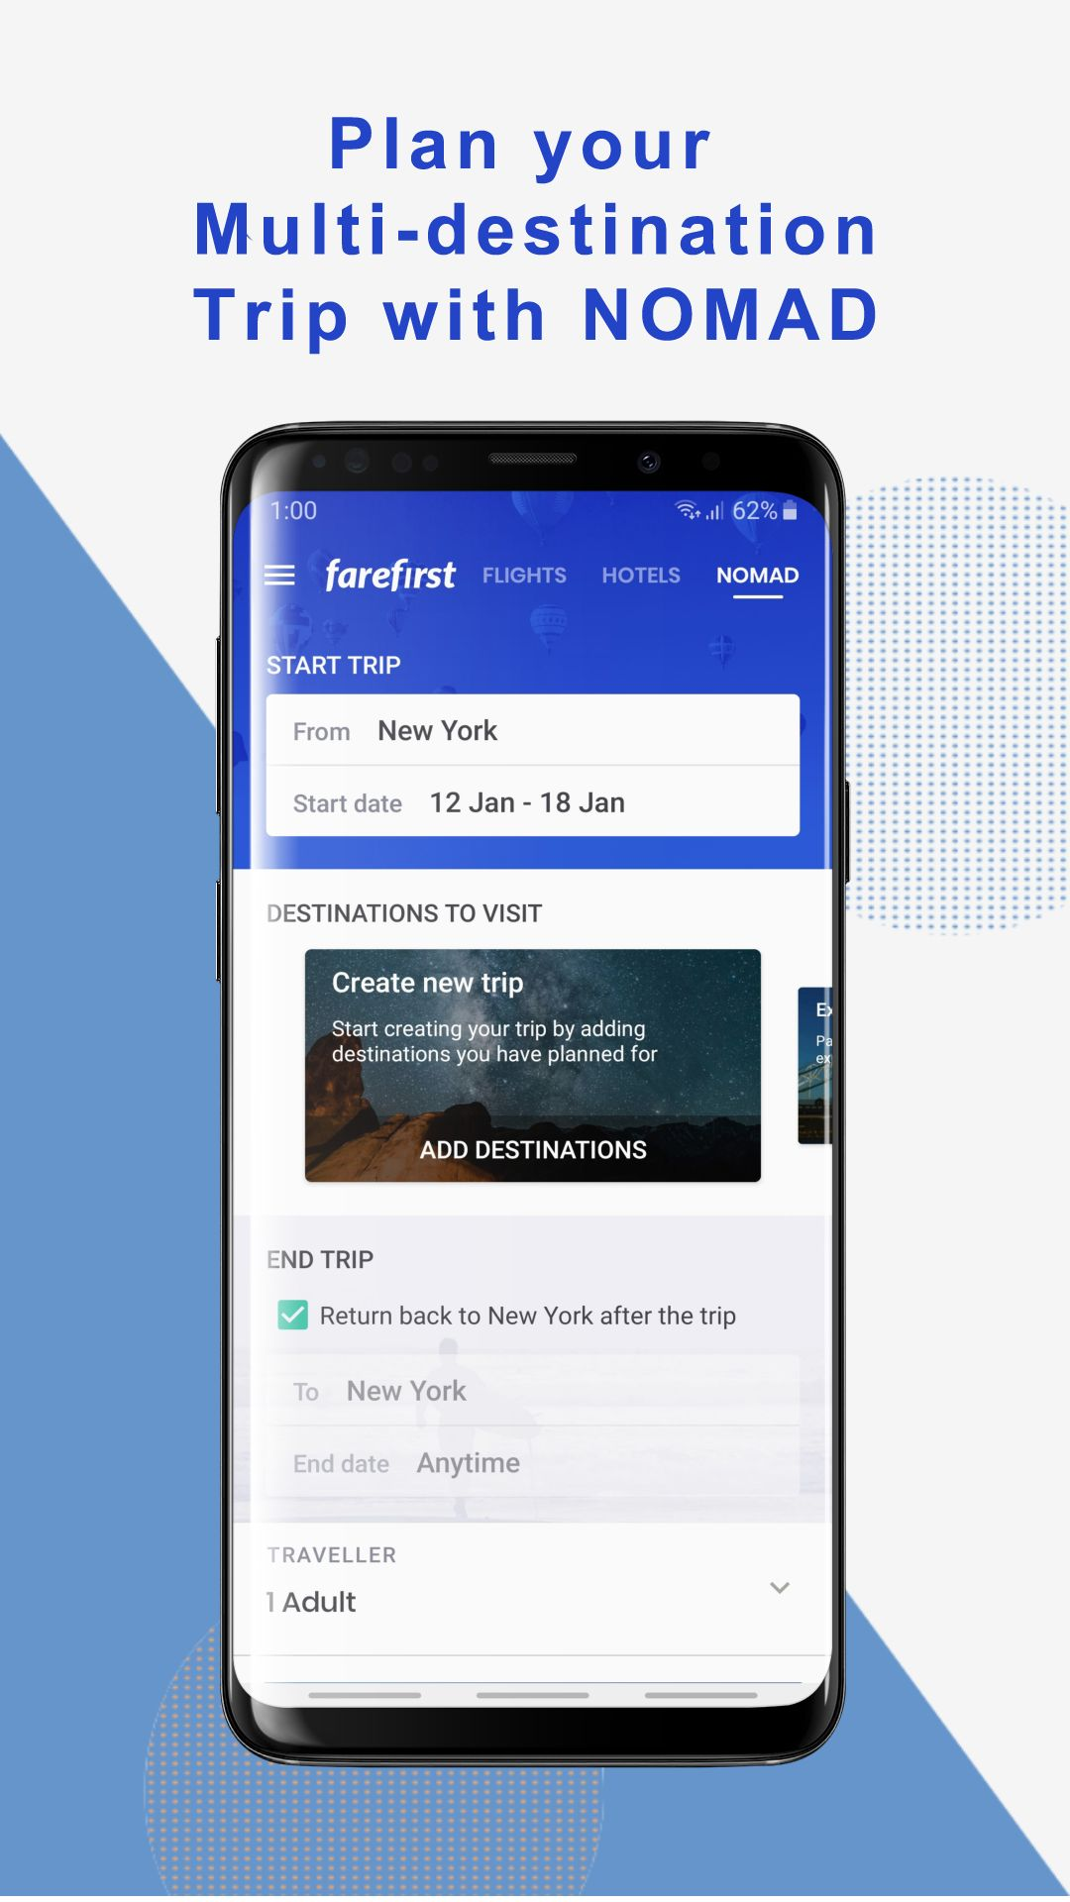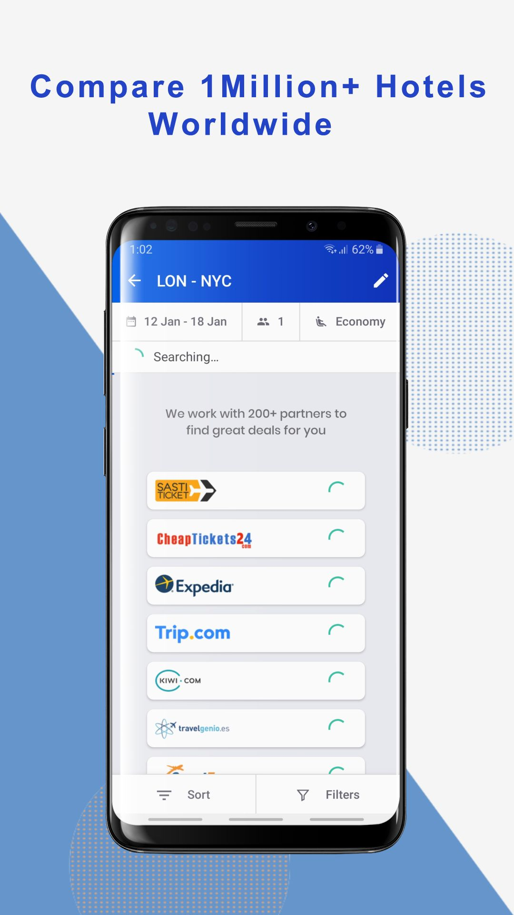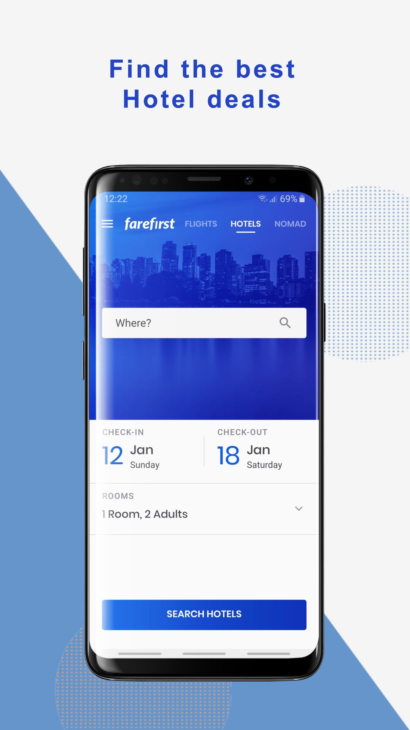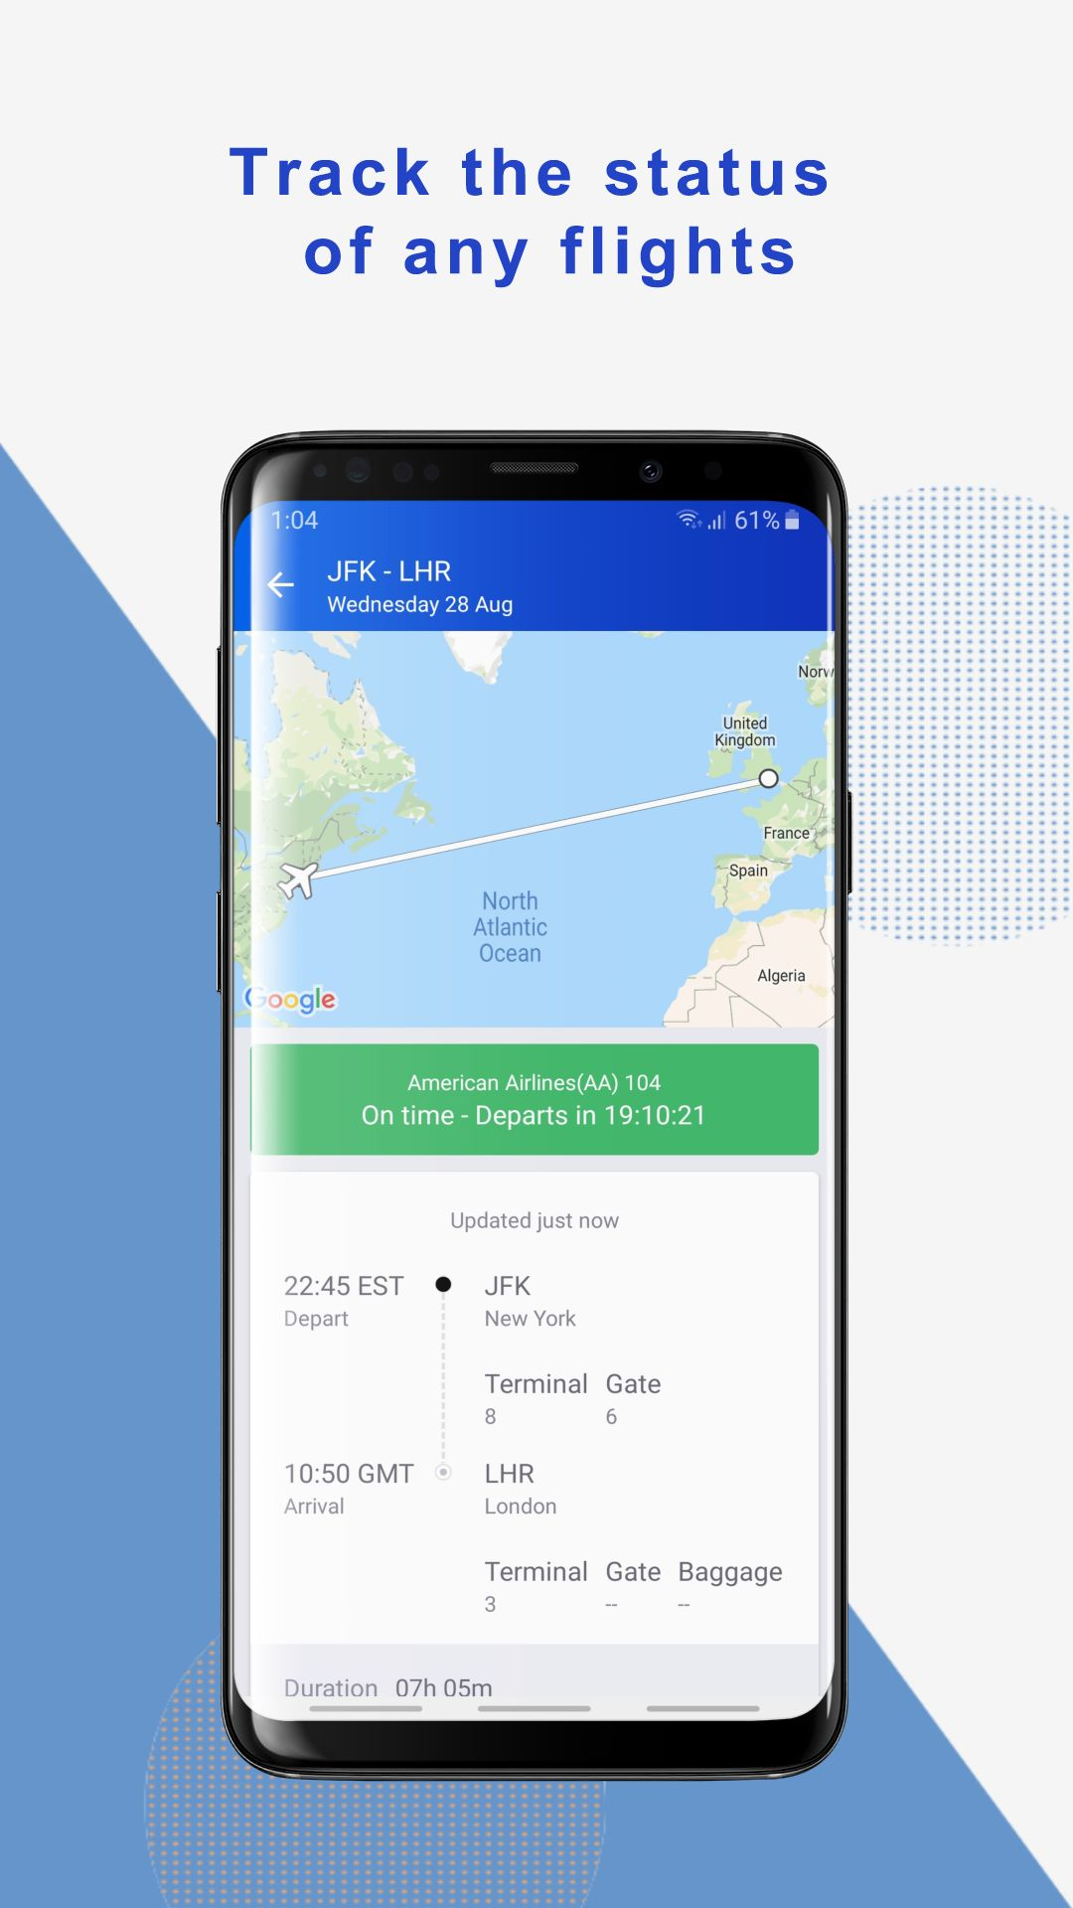

Figure 1 FareFirst

## [*Roamr*](https://alternativeto.net/software/roamr/about/)



Your dream vacation. In seconds. Planning sucks. Get a personalized day-by-day itinerary for how you travel.

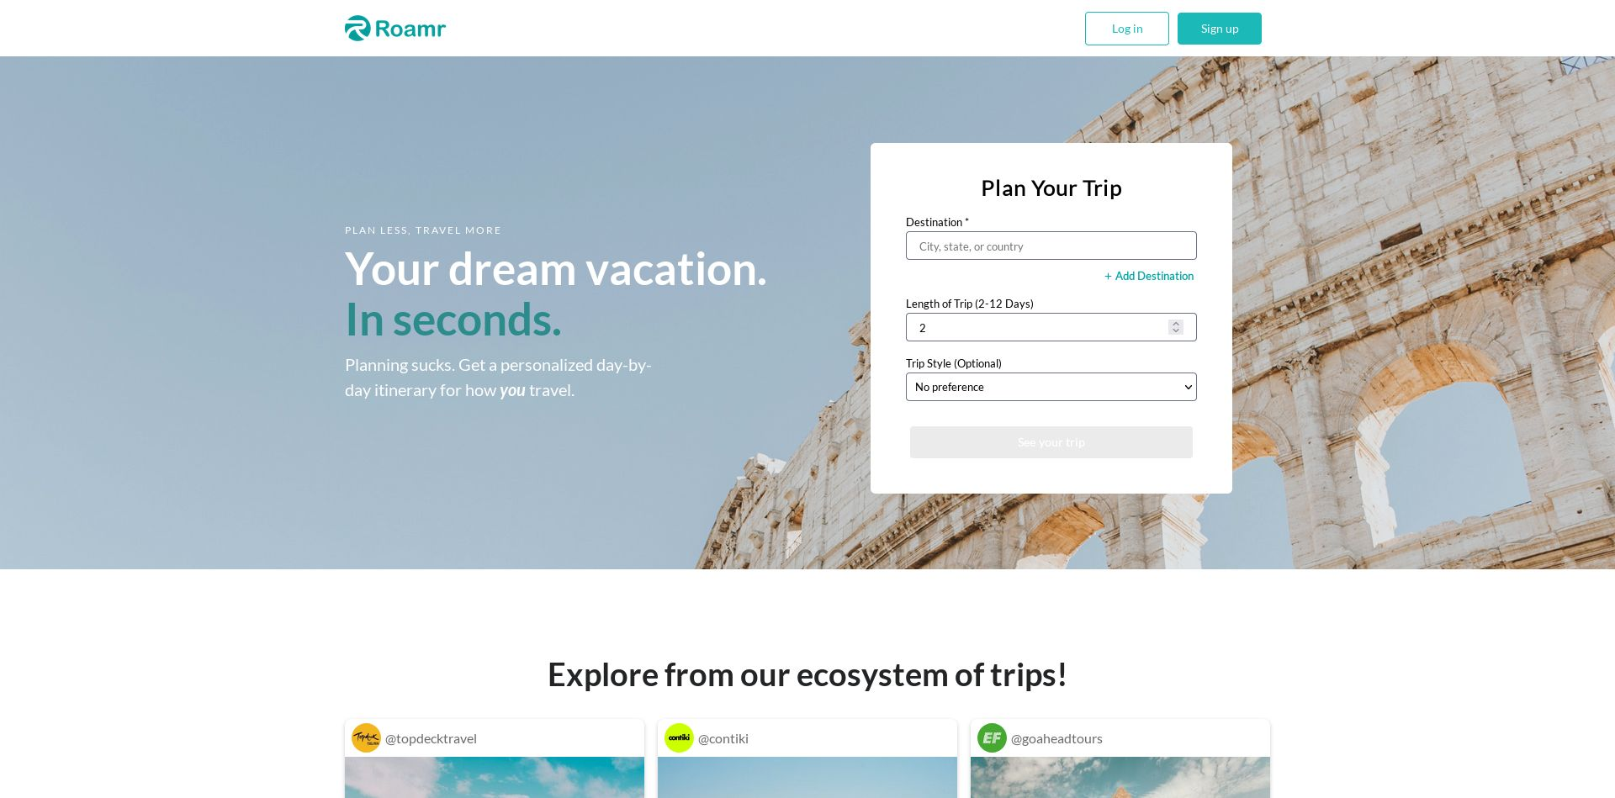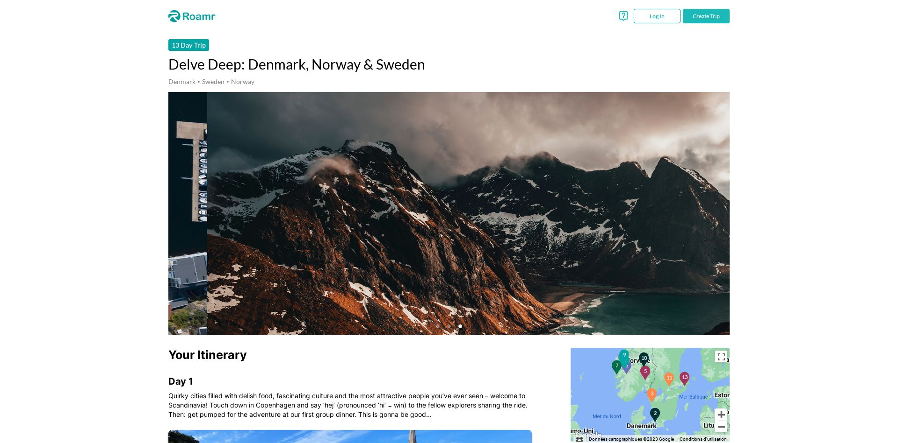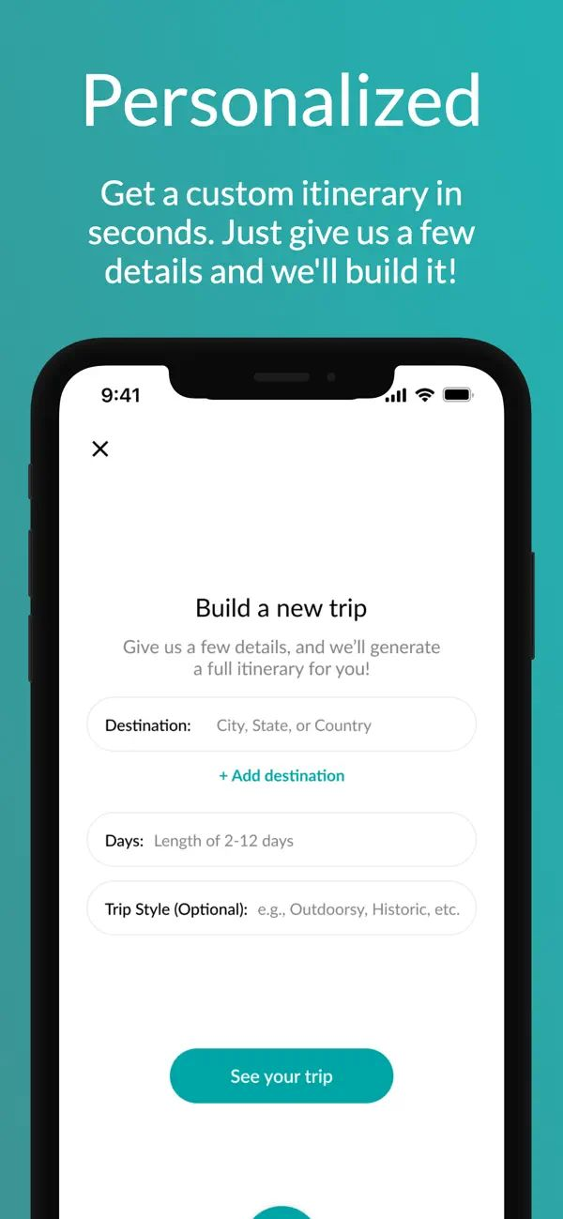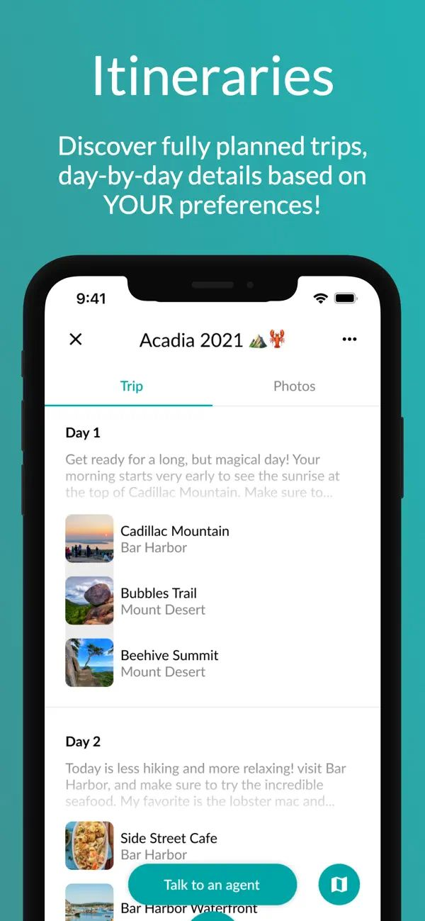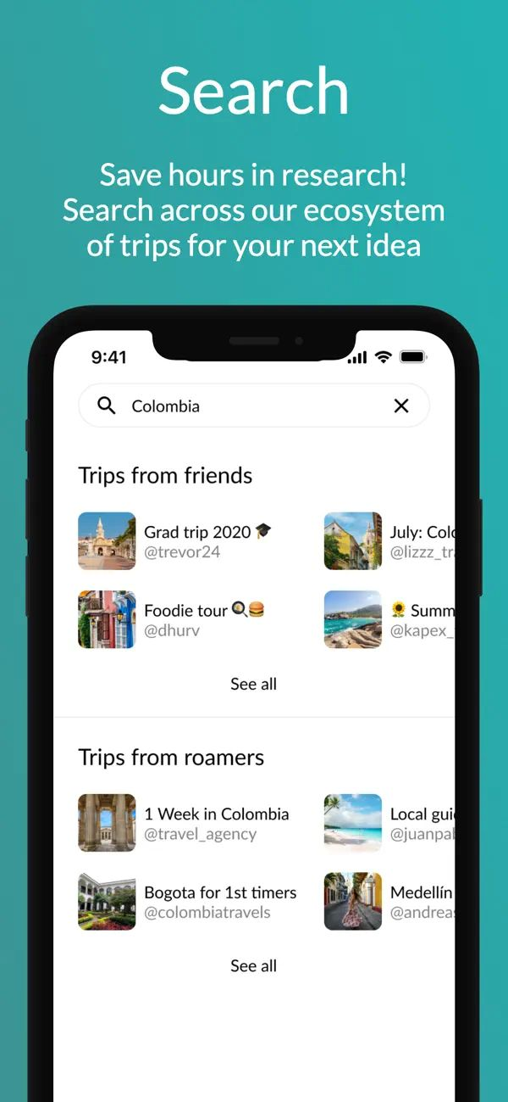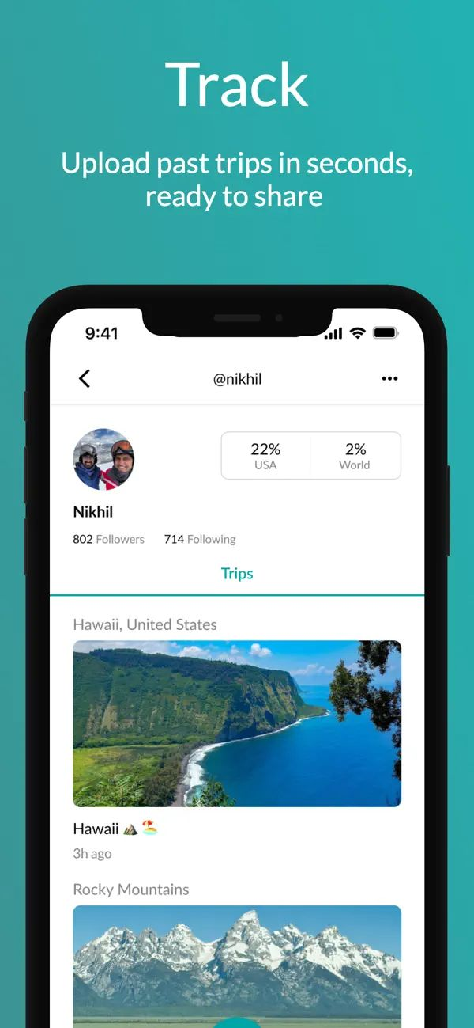

Figure 2 [Roamr](https://alternativeto.net/software/roamr/about/)

## [*Plan Harmony*](https://alternativeto.net/software/plan-harmony/about/)



* Freemium • Open Source
* [Travel Planner](https://alternativeto.net/category/travel-and-location/travel-planner/)
* [Budget Manager](https://alternativeto.net/tag/budget-manager/)
* Software as a Service (SaaS)

[2 Plan Harmony alternatives](https://alternativeto.net/software/plan-harmony/)

Collaborative trip planning app 🛫 Build your trip itinerary, set your budget, enjoy your trip. Bring harmony to planning vacations with friends & family!.

 Suggest and vote on features

### Plan Harmony Features

1. [Real time collaboration](https://alternativeto.net/feature/real-time-collaboration/)Multiple users can work together in Plan Harmony simultaneously.
2. [Ad-free](https://alternativeto.net/feature/ad-free/)Plan Harmony doesn't contain any form of external advertising.
3. [Calendar View](https://alternativeto.net/feature/calendar-view/)Plan Harmony has a built-in calendar view to have a clear overview of your content over time.

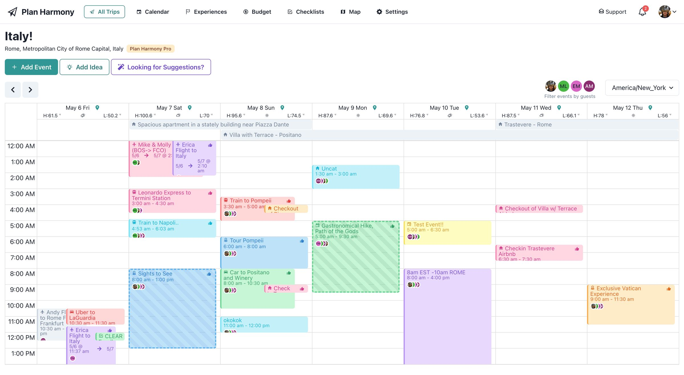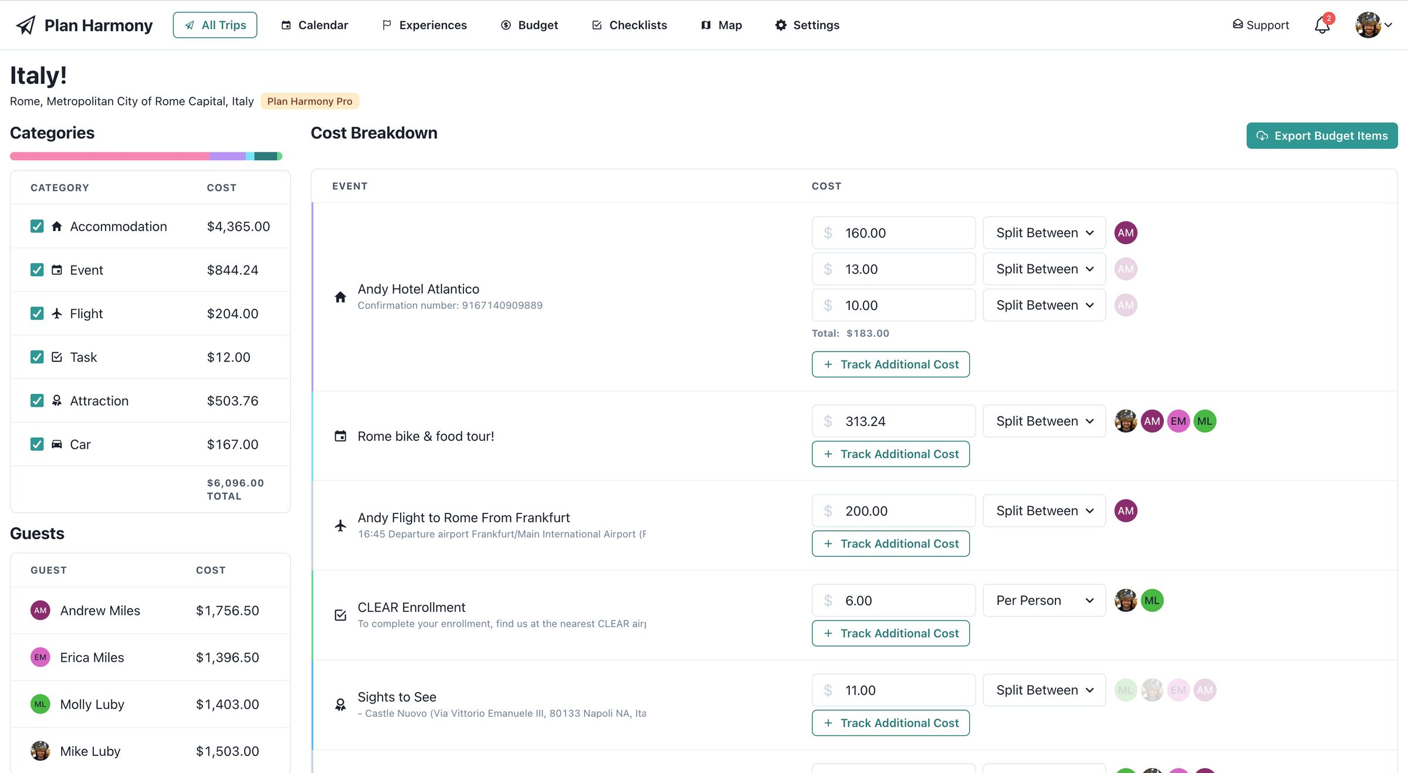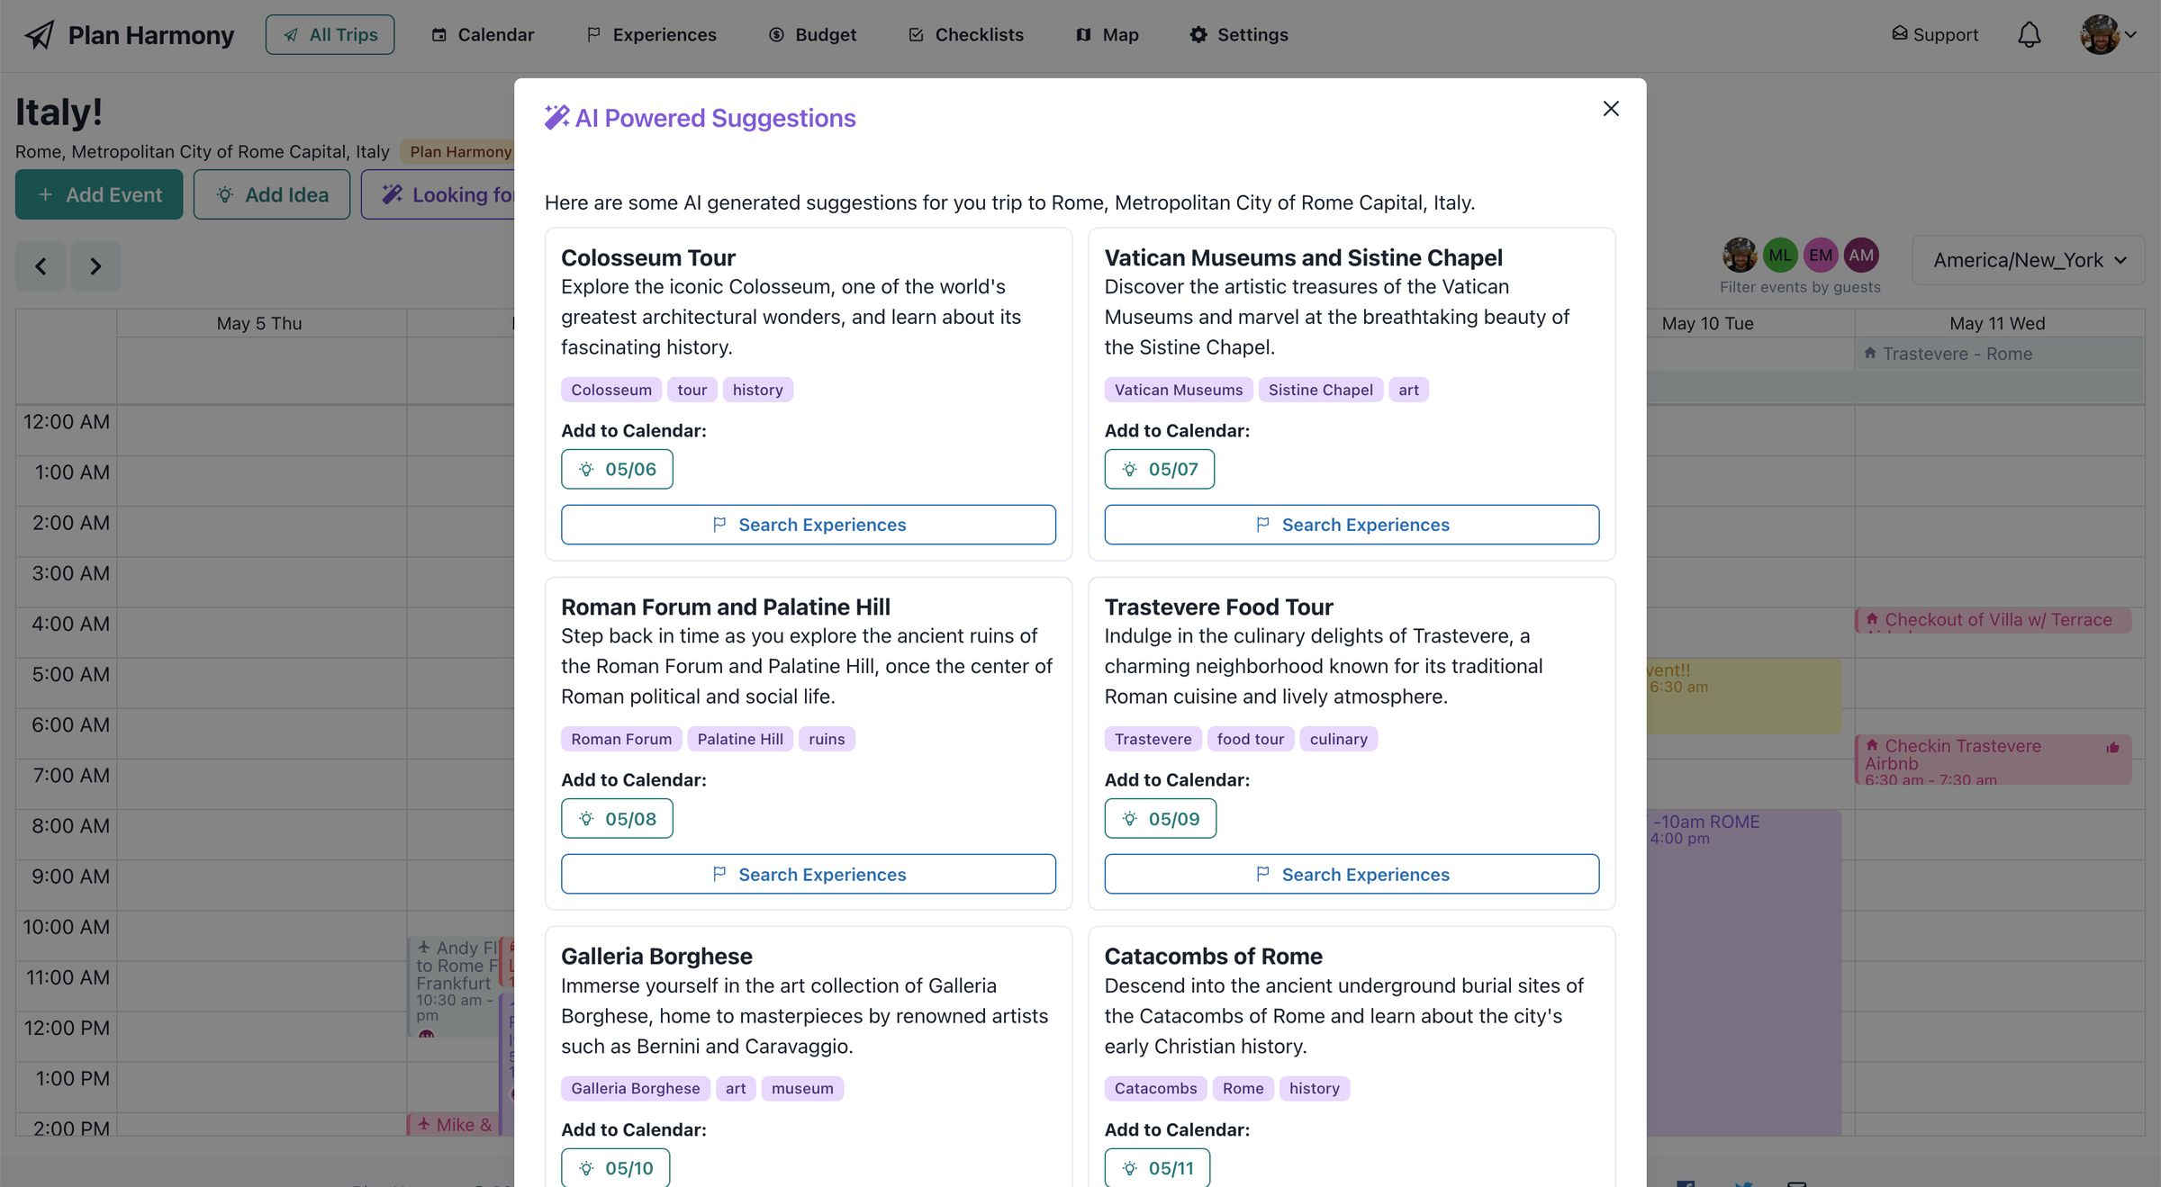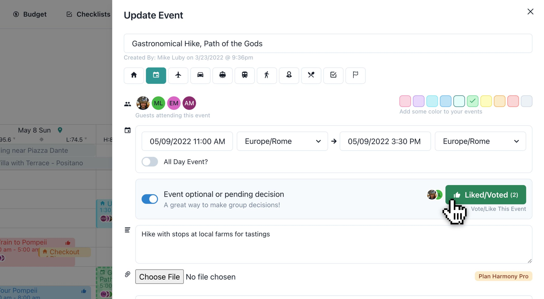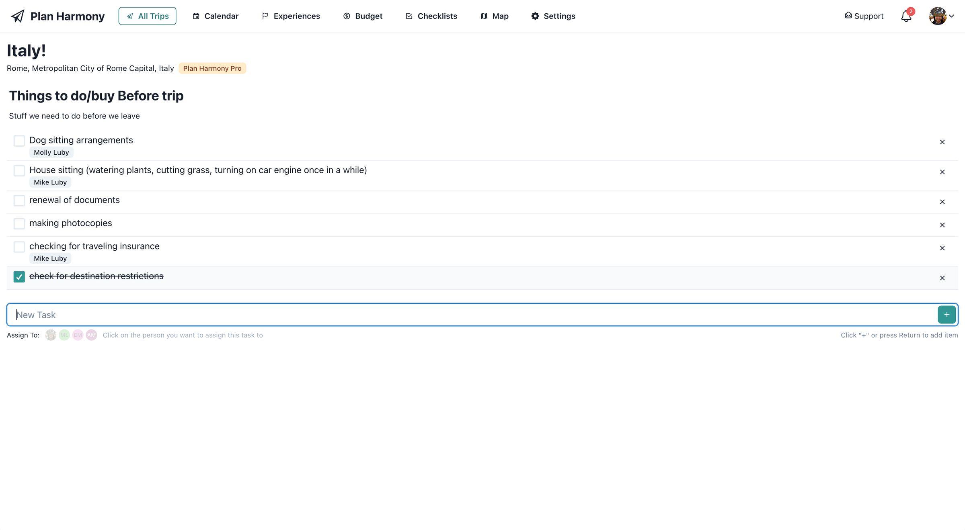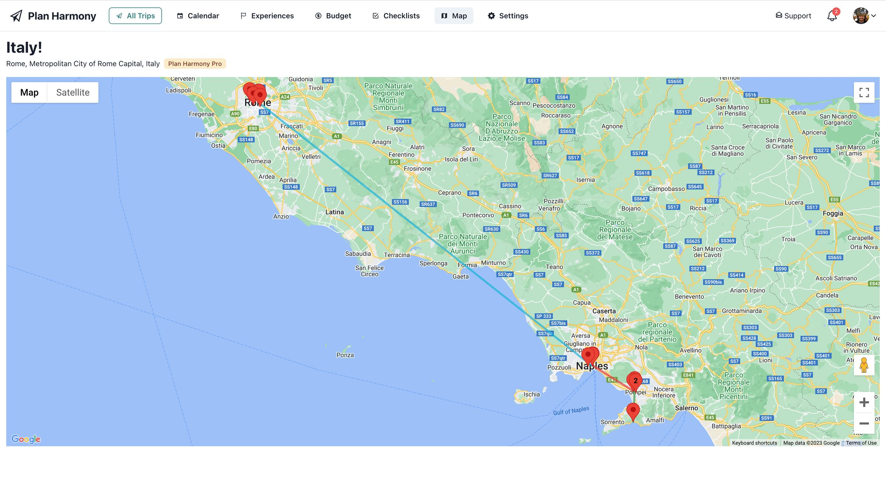

Figure 3 [Plan](https://alternativeto.net/software/roamr/about/) harmony

## *KAYAK*



Kayak.com, sometimes styled as KAYAK, is a fare aggregator and travel metasearch engine operated by the The Priceline Group.

### What is KAYAK?

KAYAK enables you to easily compare hundreds of travel sites at once, in one comprehensive, fast and intuitive display. If you want to spend hours searching every airline, hotel and other travel site yourself, that’s one option. If you’d prefer an easier way to find a good deal, we can help.

Once you find what you want, we gives you choices on where to book (most travel sites do not), including airline, hotel, car rental and online travel agency sites. We’ll send you right to the booking page to finish your purchase there. You can also book your hotel right on KAYAK with our fast, easy and secure booking process.

We also offer travel management tools including an itinerary management tool, flight status updates and price alerts.

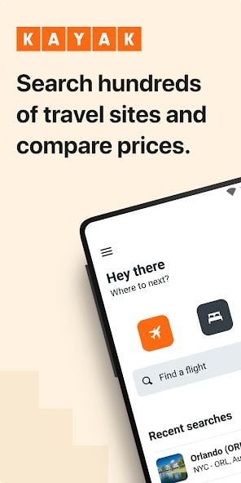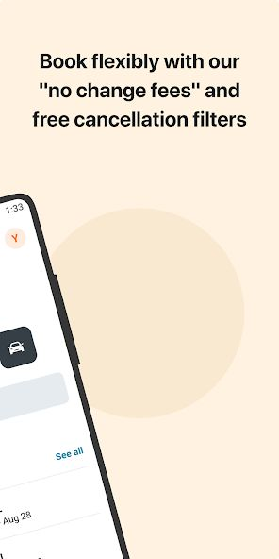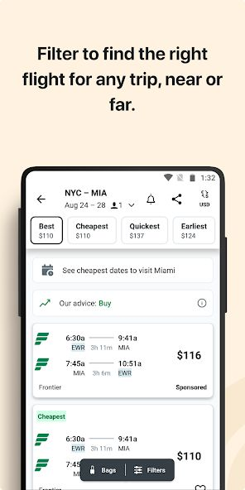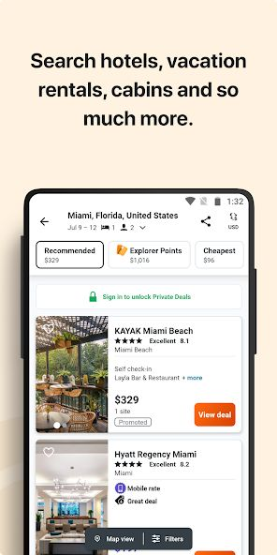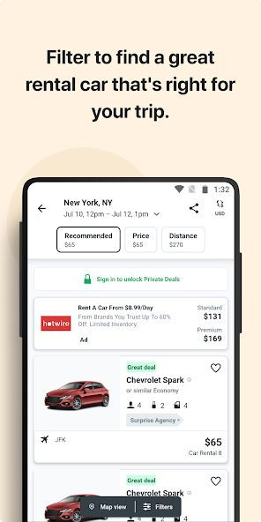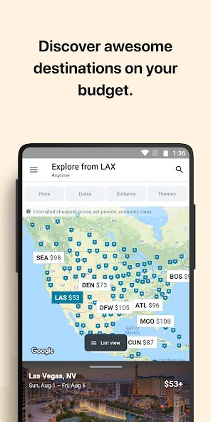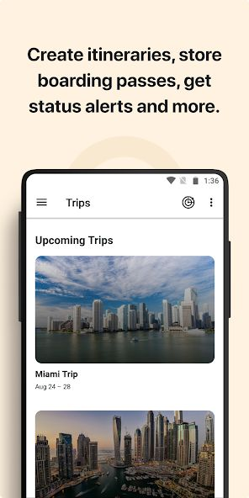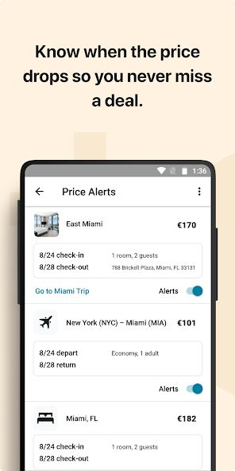

Figure 4 kayak

### KAYAK Features

* [Flight Search Engine](https://alternativeto.net/feature/flight-search-engine/)
* [Price Comparison](https://alternativeto.net/feature/price-comparison/)
* [Booking engine](https://alternativeto.net/feature/booking-engine/)
* [Price Monitoring](https://alternativeto.net/feature/price-monitoring/)
* [Flight Booking](https://alternativeto.net/feature/flight-booking/)
* [Hotel Comparison](https://alternativeto.net/feature/hotel-compare/)
* [Hotel Booking](https://alternativeto.net/feature/hotel-booking/)
* [Flight Tracker](https://alternativeto.net/feature/flights-tracking/)

## *TripIt*



Free online trip planner and free travel itinerary website for organizing vacations, group trips or business travel.

What is TripIt?

TripIt organizes your travel plans in one place. Simply forward confirmations to plans@tripit.com and we’ll do the rest. Access all your flights, hotels, car rentals, activities, maps and more on your WP7. Upgrade to TripIt Pro for peace of mind from check-in to baggage claim. Like a personal travel assistant, we’ll monitor and send you alerts for flight or fare changes. Plus, you can access all your reward accounts in one place and get additional travel perks.

TripIt Features

[Itinerary Tracker](https://alternativeto.net/feature/itinerary-tracker/)

[Itinerary Planner](https://alternativeto.net/feature/itinerary-planner/)

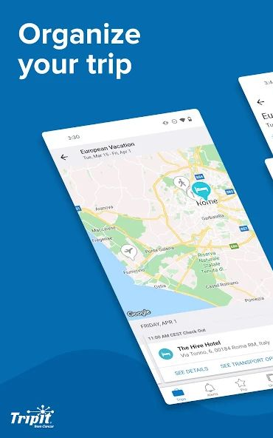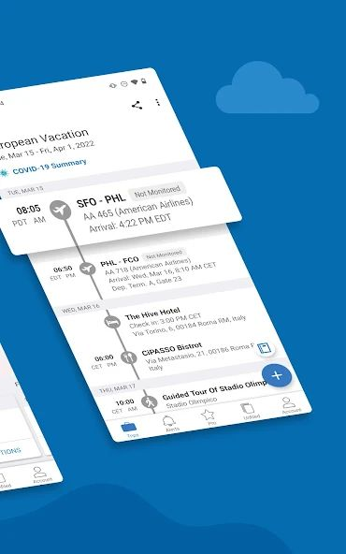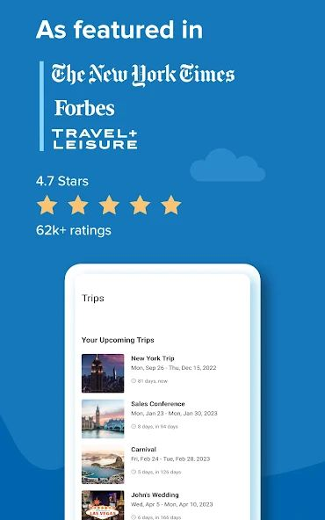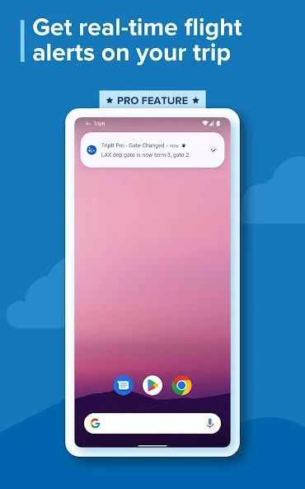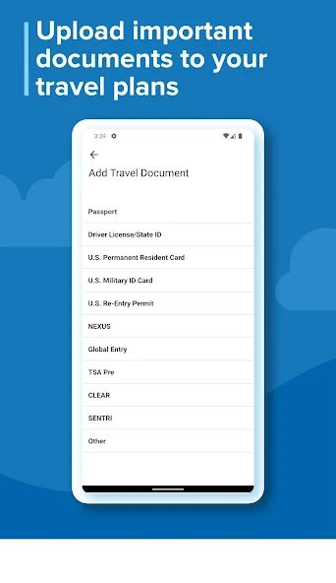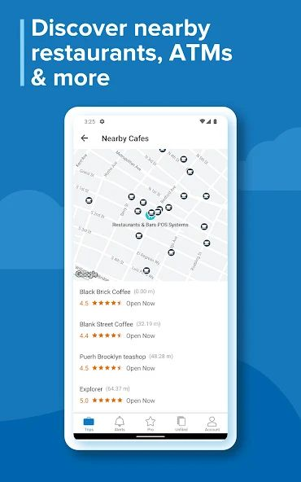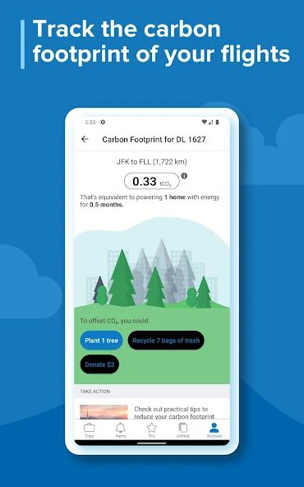

Figure 4 trip it

The existing applications, presented above, can be synthesized in the following table:

|  |  |  |  |  |
| --- | --- | --- | --- | --- |
|  | Feature 1 | Feature 2 | Feature 3 | Feature 4 |
| FareFirst |  |  |  | X |
| [Roamr](https://alternativeto.net/software/roamr/about/) | X | X |  |  |
| [Plan Harmony](https://alternativeto.net/software/plan-harmony/about/) | X |  |  |  |
| KAYAK |  | X |  | X |
| TripIt |  |  |  |  |
| vicanza |  |  |  |  |

Table 1 Comparison of Existing Similar Applications

I.4 Plan of the document

In this document, we propose a specification, design and project planning for a traveling planner

application.

We start by introducing the modeled application, its purpose, and the overall description of the application (product perspective, functions, characteristics…). Then, we discuss the external interface requirements (user interfaces, hardware interfaces, software interfaces, communication interfaces) in addition to the system features from functional to non-functional to other requirements. We talk about requirement gathering and analysis and the high-level design. Most importantly, we show some UML diagrams (use case diagram, class diagram, sequence diagram, state chart diagram) to visualize how the project will be working. And finally, we represent some future considerations.

1. Requirement Gathering, Analysis, and Specification (extension of SRS document provided by IEEE)
   1. Introduction
      1. Purpose

Identify the product whose software requirements are specified in this document, including the revision or release number. Describe the scope of the product that is covered by this SRS, particularly if this SRS describes only part of the system or a single subsystem.

* + 1. Document Conventions

Describe any standards or typographical conventions that were followed when writing this SRS, such as fonts or highlighting that have special significance. For example, state whether priorities for higher-level requirements are assumed to be inherited by detailed requirements, or whether every requirement statement is to have its own priority.

* + 1. Intended Audience and Reading Suggestions

Describe the different types of reader that the document is intended for, such as developers, project managers, marketing staff, users, testers, and documentation writers. Describe what the rest of this SRS contains and how it is organized. Suggest a sequence for reading the document, beginning with the overview sections and proceeding through the sections that are most pertinent to each reader type.

* + 1. Product Scope

Provide a short description of the software being specified and its purpose, including relevant benefits, objectives, and goals. Relate the software to corporate goals or business strategies. If a separate vision and scope document is available, refer to it rather than duplicating its contents here.

* + 1. References

List any other documents or Web addresses to which this SRS refers. These may include user interface style guides, contracts, standards, system requirements specifications, use case documents, or a vision and scope document. Provide enough information so that the reader could access a copy of each reference, including title, author, version number, date, and source or location.

* 1. Overall Description
     1. Product Perspective

Describe the context and origin of the product being specified in this SRS. For example, state whether this product is a follow-on member of a product family, a replacement for certain existing systems, or a new, self-contained product. If the SRS defines a component of a larger system, relate the requirements of the larger system to the functionality of this software and identify interfaces between the two. A simple diagram that shows the major components of the overall system, subsystem interconnections, and external interfaces can be helpful.

* + 1. Product Functions

Summarize the major functions the product must perform or must let the user perform. Details will be provided in Section 5, so only a high level summary (such as a bullet list) is needed here. Organize the functions to make them understandable to any reader of the SRS.

* + 1. User Classes and Characteristics

Identify the various user classes that you anticipate will use this product. User classes may be differentiated based on frequency of use, subset of product functions used, technical expertise, security or privilege levels, educational level, or experience. Describe the pertinent characteristics of each user class. Certain requirements may pertain only to certain user classes. Distinguish the most important user classes for this product from those who are less important to satisfy.

* + 1. Operating Environment

Describe the environment in which the software will operate, including the hardware platform, operating system and versions, and any other software components or applications with which it must peacefully coexist.

* + 1. Design and Implementation Constraints

Describe any items or issues that will limit the options available to the developers. These might include: corporate or regulatory policies; hardware limitations (timing requirements, memory requirements); interfaces to other applications; specific technologies, tools, and databases to be used; parallel operations; language requirements; communications protocols; security considerations; design conventions or programming standards (for example, if the customer’s organization will be responsible for maintaining the delivered software).

* + 1. User Documentation

List the user documentation components (such as user manuals, on-line help, and tutorials) that will be delivered along with the software. Identify any known user documentation delivery formats or standards.

* + 1. Assumptions and Dependencies

List any assumed factors (as opposed to known facts) that could affect the requirements stated in the SRS. These could include third-party or commercial components that you plan to use, issues around the development or operating environment, or constraints. The project could be affected if these assumptions are incorrect, are not shared, or change. Also identify any dependencies the project has on external factors, such as software components that you intend to reuse from another project, unless they are already documented elsewhere (for example, in the vision and scope document or the project plan).

* 1. External Interface Requirements
     1. User Interfaces

Describe the logical characteristics of each interface between the software product and the users. This may include sample screen images, any GUI standards or product family style guides that are to be followed, screen layout constraints, standard buttons and functions (e.g., help) that will appear on every screen, keyboard shortcuts, error message display standards, and so on. Define the software components for which a user interface is needed. Details of the user interface design should be documented in a separate user interface specification.

* + 1. Hardware Interfaces

Describe the logical and physical characteristics of each interface between the software product and the hardware components of the system. This may include the supported device types, the nature of the data and control interactions between the software and the hardware, and communication protocols to be used.

* + 1. Software Interfaces

Describe the connections between this product and other specific software components (name and version), including databases, operating systems, tools, libraries, and integrated commercial components. Identify the data items or messages coming into the system and going out and describe the purpose of each. Describe the services needed and the nature of communications. Refer to documents that describe detailed application programming interface protocols. Identify data that will be shared across software components. If the data sharing mechanism must be implemented in a specific way (for example, use of a global data area in a multitasking operating system), specify this as an implementation constraint.

* + 1. Communications Interfaces

Describe the requirements associated with any communications functions required by this product, including e-mail, web browser, network server communications protocols, electronic forms, and so on. Define any pertinent message formatting. Identify any communication standards that will be used, such as FTP or HTTP. Specify any communication security or encryption issues, data transfer rates, and synchronization mechanisms.

* 1. Requirements Gathering

State your strategy to gather the requirements: questionnaire, iterations on several prototypes, Interviews, etc… **Explain the sequel of the information and requirements gathering phase.**

Give samples of sketches and/or prototype GUI screenshots, for example:

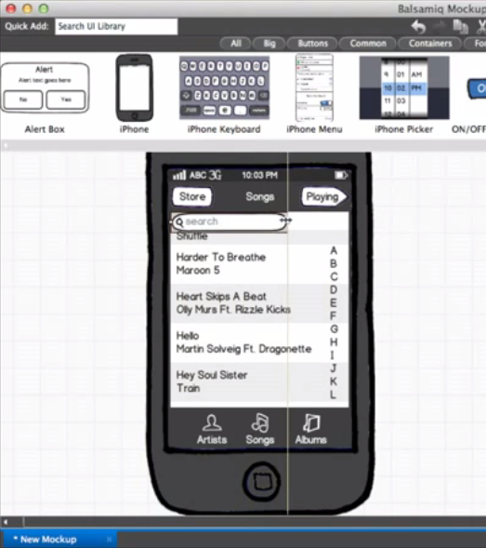

Figure 4 Sample Sketch Mockup

Famous Mockup Tools:

* <http://www.balsamiq.com>
* <https://moqups.com>
* <http://www.axure.com>
* <https://www.adobe.com/products/xd.html>
  1. System Features

This template illustrates organizing the functional requirements for the product by system features, the major services provided by the product. You may prefer to organize this section by use case, mode of operation, user class, object class, functional hierarchy, or combinations of these, whatever makes the most logical sense for your product.

* + 1. System Feature 1

**Don’t really say “System Feature 1.” State the feature name in just a few words.**

* Description and Priority

Provide a short description of the feature and indicate whether it is of High, Medium, or Low priority. You could also include specific priority component ratings, such as benefit, penalty, cost, and risk (each rated on a relative scale from a low of 1 to a high of 9).

* Stimulus/Response Sequences

List the sequences of user actions and system responses that stimulate the behavior defined for this feature. These will correspond to the dialog elements associated with use cases.

* Functional Requirements

Itemize the detailed functional requirements associated with this feature. These are the software capabilities that must be present in order for the user to carry out the services provided by the feature, or to execute the use case. Include how the product should respond to anticipated error conditions or invalid inputs. Requirements should be concise, complete, unambiguous, verifiable, and necessary. Use “TBD” as a placeholder to indicate when necessary information is not yet available.

Each requirement should be uniquely identified with a sequence number or a meaningful tag of some kind.

REQ-1:

REQ-2:

* + 1. System Feature 2 (and so on)
  1. Other Nonfunctional Requirements
     1. Performance Requirements

If there are performance requirements for the product under various circumstances, state them here and explain their rationale, to help the developers understand the intent and make suitable design choices. Specify the timing relationships for real time systems. Make such requirements as specific as possible. You may need to state performance requirements for individual functional requirements or features.

* + 1. Safety Requirements

Specify those requirements that are concerned with possible loss, damage, or harm that could result from the use of the product. Define any safeguards or actions that must be taken, as well as actions that must be prevented. Refer to any external policies or regulations that state safety issues that affect the product’s design or use. Define any safety certifications that must be satisfied.

* + 1. Security Requirements

Specify any requirements regarding security or privacy issues surrounding use of the product or protection of the data used or created by the product. Define any user identity authentication requirements. Refer to any external policies or regulations containing security issues that affect the product. Define any security or privacy certifications that must be satisfied.

* + 1. Software Quality Attributes

Specify any additional quality characteristics for the product that will be important to either the customers or the developers. Some to consider are: adaptability, availability, correctness, flexibility, interoperability, maintainability, portability, reliability, reusability, robustness, testability, and usability. Write these to be specific, quantitative, and verifiable when possible. At the least, clarify the relative preferences for various attributes, such as ease of use over ease of learning.

* + 1. Business Rules

List any operating principles about the product, such as which individuals or roles can perform which functions under specific circumstances. These are not functional requirements in themselves, but they may imply certain functional requirements to enforce the rules.

* 1. Other Requirements

Define any other requirements not covered elsewhere in the SRS. This might include database requirements, internationalization requirements, legal requirements, reuse objectives for the project, and so on. Add any new sections that are pertinent to the project.

* 1. Requirements Analysis

List the collected and identified requirements. For each, state the category based on the Audience-Oriented Requirements. Criticize the given set of required features**, especially if you do not agree with the client, or if you are unable to justify them**, or unable to imagine whether you will succeed in fulfilling 2 or more conflicting requirements.

**Based on MOSCOW Method, prioritize your requirements.** For every non-functional requirement, **explain how to verify and validate it with the client**.

* + 1. Use Cases

To draw your UML diagrams, use a computerized tool such as Modelio[1] or StarUML[2] or Visual Pradigm[3]. **Mandatory**… Give the whole UC diagram then explain and justify all the association in it (extends, includes and inheritance).

* + 1. Use Cases Textual Description

Good to have it for the couple of main functionalities… optional for the rest. The following is a sample use case detailed textual description:

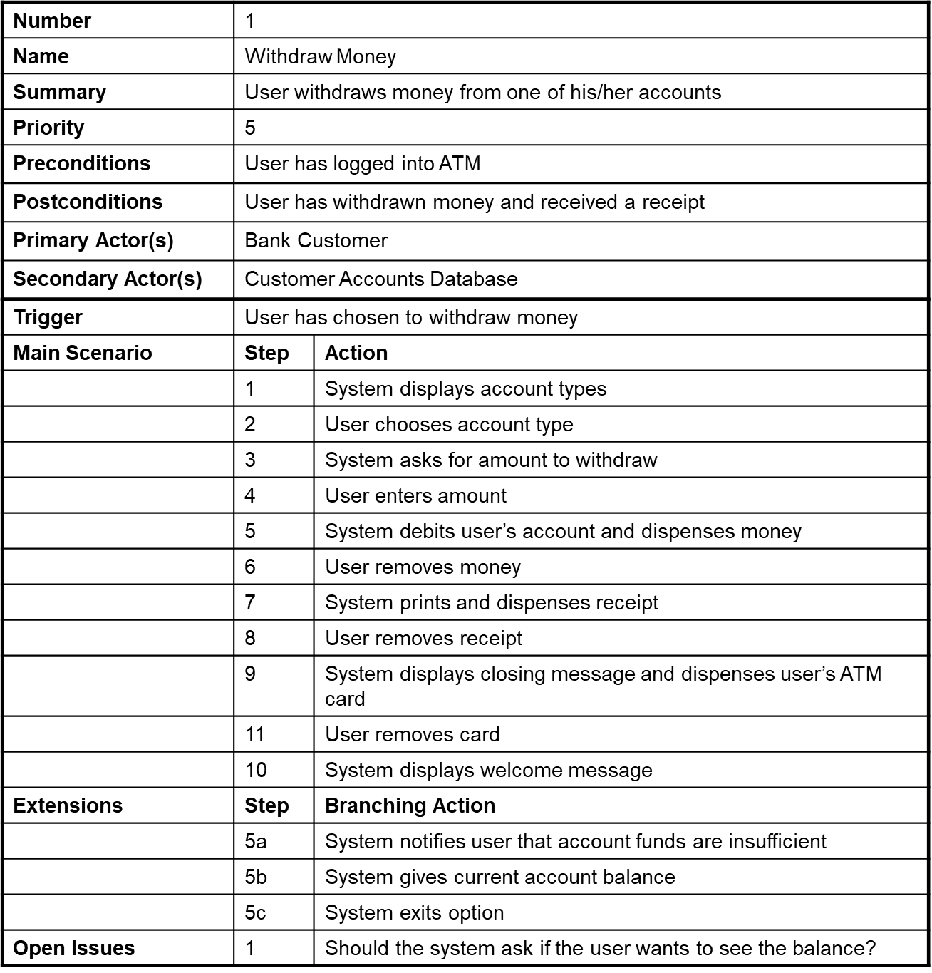

Figure 5: Example for a DTD

* 1. High-Level Design Specification

Exactly what you should **specify** in the high‐level design varies somewhat, but some things are constant for most projects.

* Security
* Hardware
* User Interface
* Internal Interfaces
* External Interfaces
* Architecture
* Reports
* Database
  1. Conclusion

This chapter presented…

Difficulties encountered in gathering the data, if any, and the followed approach to overcome them (ask the client for more details, check and get inspired by existing similar apps, leaving the questions open till being answered in an agile reactive way later on during the development phase…)

1. Application Conception
   1. Introduction

In the previous chapters, we have talked about the features that should be offered by our application... This reveals that the following entities are implied in the process… In this chapter we give, using UML class diagrams, the conceptual model that clarifies these entities, their underlying handled data, roles in the application and associations with each other.

* 1. Database

Database is “a structured set of data held in a computer, especially one that is accessible in various ways.” There are various types of databases, each providing different functionality to their users. In this section, you should present your DB type/structure needed for you project.

* 1. UML Class Diagram

The whole picture can be cut into several smaller diagrams, each focusing on a specific set of interrelated entities and concepts.

Every diagram should be well annotated and explained in the sequel. Every choice made (association, cardinality, abstraction, etc.) and every used symbol should be justified and well explained.

* 1. Sequence Diagrams

Can be given for the main scenarios to show the sequence of functions calls between **objects and instances of the various proposed classes**.

* 1. State Chart Diagram

Opt for state chart diagrams only if one (or more) of your key and central entities change state as the process progresses and when different use cases are executed, and you want to capture this crucial business logic.

* 1. Conclusion

This chapter presented our application design. First, we introduced…

After that, we presented...

In the next chapter, we make a complete feasibility study and draw out the plan of our project realization, risk management and client support and satisfaction strategy...

1. Conclusion

About the whole project…

Discussion of the lived experience and the obtained results.

* 1. Future Considerations

Pointers toward future work, especially if you are really willing to implement the proposed application.

## Bibliography

|  |  |
| --- | --- |
| [1] | Summerville, Software Engineering, Pearson, 2014.  [2] Beginning Software Engineering, Rod Stephens. John Wiley & Sons, Inc. |
|  |  |

## Note about the bibliography [to be deleted from the final document]

The bibliography should only contain valid references, i.e. books, journal articles and companies’ white papers. URLs, such as Wikipedia, forums, normal blogs and web pages are not valid references. In case you used them in the document, then put them in footnotes.

1. <https://www.modelio.org/>
2. <http://staruml.io/>
3. <https://www.visual-paradigm.com/>